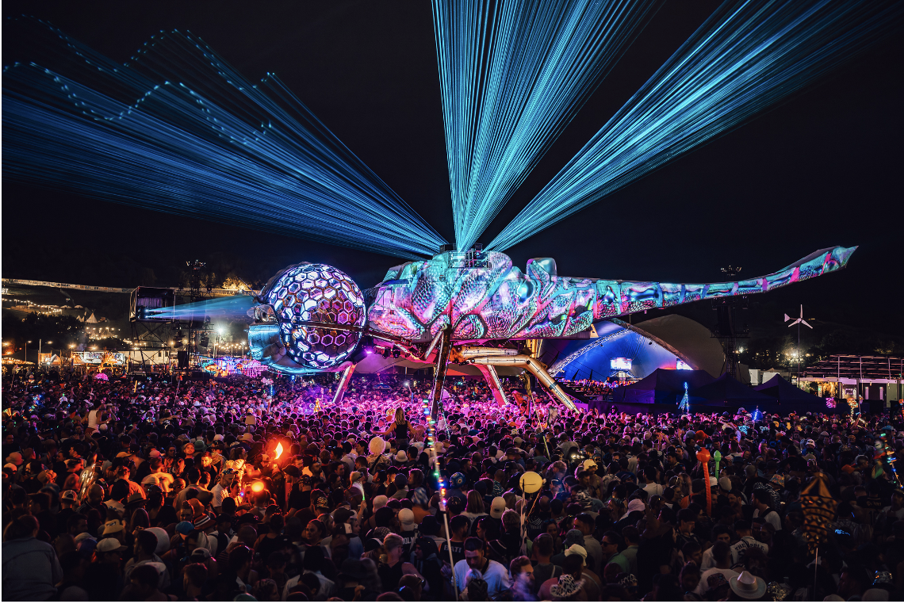
Picture credit: @shotawaydotcom and @arcadia

Sennheiser Spectera helps Arcadia’s Dragonfly soar at Glastonbury 2025
Wireless audio innovation supports spectacular live performances

Marlow, UK, 24 July 2025 – This year’s Glastonbury festival witnessed the return of performance art collective Arcadia Spectacular and their iconic Dragonfly Stage, an extraordinary 13-metre-long installation crafted from a transformed Sea King military helicopter. The colossal metallic sculpture dominated the festival landscape, reimagined as a living creature through dynamic projection mapping, LED illumination, and upgraded laser technology integrated into its wing structures. Founded by creative engineers Bertie Cole and Pip Rush, Arcadia debuted at Glastonbury in 2007 and has held a permanent area since 2014. This year marked a significant wireless evolution for Arcadia, with Sennheiser’s revolutionary Spectera wireless system delivering pristine audio performance in one of the most demanding RF environments in the world.

Kevin Gwyther-Brown, Business Development Manager – Professional Audio at Sennheiser, has worked closely with Arcadia for the past year, building a relationship that has evolved alongside the technology. “The Arcadia team has been familiar with Spectera since the system was announced at IBC 2024. Their vision was always to move to Spectera, and it came to fruition at this year’s festival,” he says. “For me, this is all about the evolution of the relationship between Arcadia and Sennheiser, both in terms of our collaboration and the equipment being utilised. We were able to implement the use of Spectera this year following a conversation between Bertie and I about trying out new technology on the Dragonfly.”

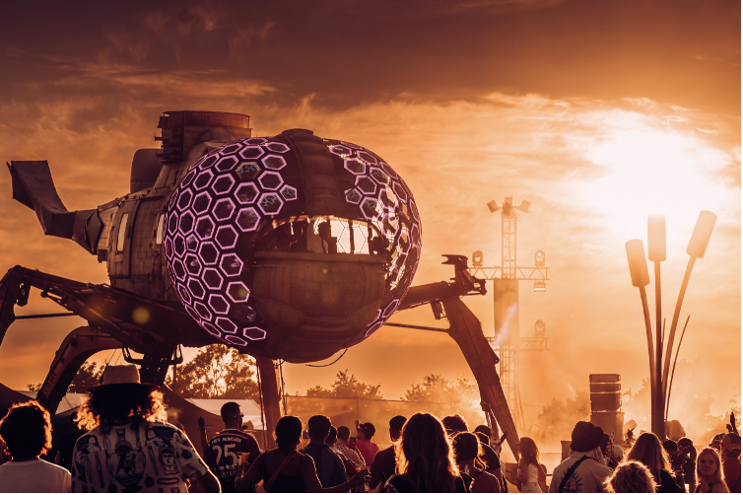 | The colossal metallic sculpture dominated the festival landscape, reimagined as a living creature through dynamic projection mapping, LED illumination, and upgraded laser technology integrated into its wing structures  Picture credit:  Matt Eachus (TheMancPhotographer)

The timing proved fortuitous, as upgrades to the Dragonfly’s lighting and laser systems provided the perfect opportunity to enhance the audio and RF capabilities alongside these other technical improvements. The collaboration extended beyond Sennheiser to include industry partners, with input from Paul Rose and the team from audio rental company AF Live adding valuable expertise to the project.

The 2025 Dragonfly installation presented unique challenges, requiring reliable wireless coverage across a large area while maintaining audio quality in a busy festival landscape. The performance takes place suspended above the audience, inside a near 100-metre diameter ring of inward facing PA towers. Since the stage is well within the PA coverage, and therefore subject to significant delay, IEMs are essential for all performers, even those not accustomed to using them. Pre-show checks are critical to ensure each artist is comfortable with their mix before entering the structure.

“To meet this need, we required three distinct IEM coverage zones: backstage (for soundcheck), FOH (for engineers to monitor via the same system), and inside the structure,” explains Rob Cook, FOH Engineer for the Arcadia Dragonfly Stage. “The performance area is enclosed in a sphere of custom LED panels, which also functions as a surprisingly effective Faraday cage.”

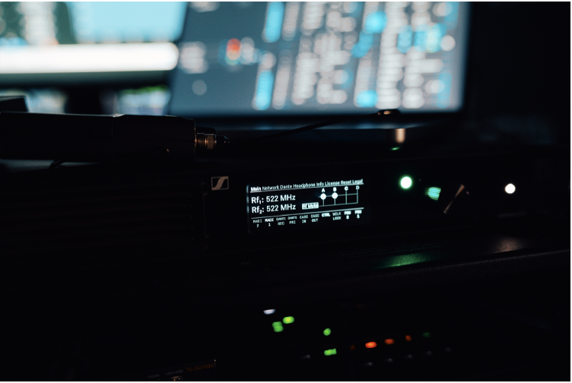 | The Spectera Base Station was located at FOH and connected directly to the mixing console via MADI, ensuring seamless integration with the existing audio infrastructure  Picture credit:  @shotawaydotcom

Sennheiser’s audio solution centred on the new Spectera wireless system, which took centre stage in delivering solid performance across the demanding RF environment. Spectera is the world’s first wideband, bidirectional digital wireless ecosystem, offering up to 64 channels (32 in/32 out) in a single rack unit. Spectera’s Audio Link modes provide unprecedented control of latency, audio quality and more for each link, while its bidirectional bodypacks manage both in-ear monitor and mic/line signals simultaneously.

Six Spectera SEK bodypacks delivered IEM mixes for DJ and MC monitoring, while also providing monitoring for featured artists including Becky Hill, offering reliability, flexibility, and clean coverage across the site. The system’s ability to connect multiple antennas to a single Base Station to extend coverage meant that one antenna could be positioned inside the helicopter structure, and another at the front-of-house position, providing excellent range extension across the festival field. The Base Station was located at FOH and connected directly to the mixing console via MADI, seamlessly integrating with the existing audio infrastructure.

“Spectera made this setup effortless,” says Cook. “We placed the Base Station at FOH with a local antenna that also covered the entire Arcadia field. A second antenna, connected via a 100-metre ethercon run, was installed at the structure entrance with direct line of sight to the performers. Both antennas transmitted and received on the same TV channel, providing seamless, dropout-free coverage across the field, even including catering.”

“We can’t deploy vocal monitors due to the limited space, which makes the IEM system absolutely vital,” adds Jacob Kuenzler-Byrt, Stage Manager and Deputy Technical Manager at Arcadia. “Spectera’s power and pristine clarity delivered across the board, allowing each vocal artist to immediately feel comfortable and connected in such a unique environment. The coverage of the entire arena, as well as the stage, was flawless, and the options it creates for dispersed performance elements are really exciting. This extended coverage was a huge improvement from 2024.”

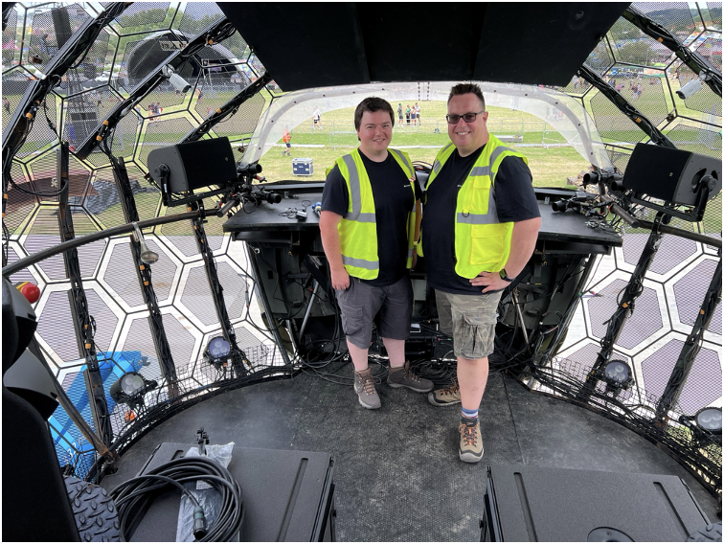 | Sennheiser's Marcus Blight, Technical Application Engineer, and Kevin Gwyther-Brown, Business Development Manager – Professional Audio, both offered support for the flawless deployment of the Sennheiser Spectera system at the Dragonfly Stage during Glastonbury 2025

Meanwhile, four channels of EW-DX handheld transmitters, equipped with MM 435 capsules, handled DJ and MC vocal duties in a hybrid side-by-side configuration. A pair of omni-directional active antennas were installed inside the helicopter, with the EW-DX microphones operating exclusively within the Dragonfly body and running analogue signals to an SD rack.

Marcus Blight, Technical Application Engineer at Sennheiser, worked alongside Gwyther-Brown to ensure flawless deployment. Both arrived ahead of the show opening to carry out RF checks and ensure everything was locked in and ready – a crucial step in an environment as RF-heavy as Glastonbury.

“RF robustness, flexibility and scalability allowed the team to provide solid coverage across a large area of the site,” Blight notes. “Spectera offered a massive sonic advantage, offering low-latency digital audio to the IEM users and a fast, easy deployment for the crew, who were surprised how simple the system is to use. EW-DX, combined with the MM 435 capsules, provided vocal clarity that cut through the track and immersed the audience.”

For this year’s Dragonfly Stage, Spectera offered a massive sonic advantage, offering low-latency digital audio to the IEM users and a fast, easy deployment for the crew, who were surprised how simple the system is to use  Picture credit:  @shotawaydotcom | 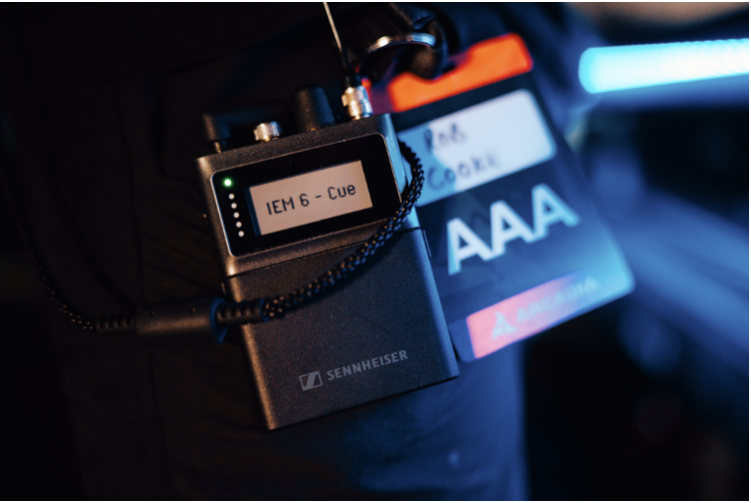

“The sound quality of Spectera is unmatched,” adds Cook. “It feels like using a high-end studio headphone amp. The lack of noise floor, superb stereo separation, and flawless coverage allowed me to mix nearly the entire weekend through IEMs. With a suboptimal FOH location and the constant need to stay on comms during Arcadia’s show, that reliability was invaluable.”

Kuenzler-Byrt approached the 2025 setup with knowledge gained from the previous year’s outing. The trust and collaboration between the teams resulted in a setup that was not only more efficient but also forward-looking, aligning with Arcadia's ever-evolving creative and technical ambitions.

Upgrades to the Dragonfly’s lighting and laser systems provided the perfect opportunity to enhance the audio and RF capabilities alongside these other technical improvements  Picture credit:  Matt Eachus (TheMancPhotographer) | 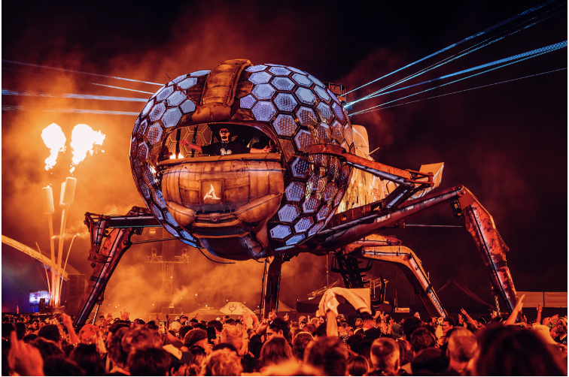

“Sennheiser have been brilliant since the collaboration began in 2024, and the support from Kevin and Marcus has been incredible, especially on such an unconventional production,” he says. “It’s an absolute pleasure to work with such a professional team and we’re very excited to keep building new avenues together.”

“The evolution of our work with Arcadia represents everything we strive for in relationships,” concludes Gwyther-Brown. “From our initial collaboration in 2024 to this year’s full Spectera deployment, we’ve grown together, with each project pushing the boundaries of what’s possible in live performance technology.”

Spectera was also used for Nile Rodgers & Chic’s performance on the Pyramid Stage, along with Dhani Harrison’s Friday slot on the Acoustic Stage.

As well as the Dragonfly Stage by Arcadia Spectacular, Sennheiser’s Spectera was also used for Nile Rodgers & Chic’s performance on the Pyramid Stage, along with Dhani Harrison’s Friday slot on the Acoustic Stage at this year’s Glastonbury  Picture credit:  Charlie Raven | 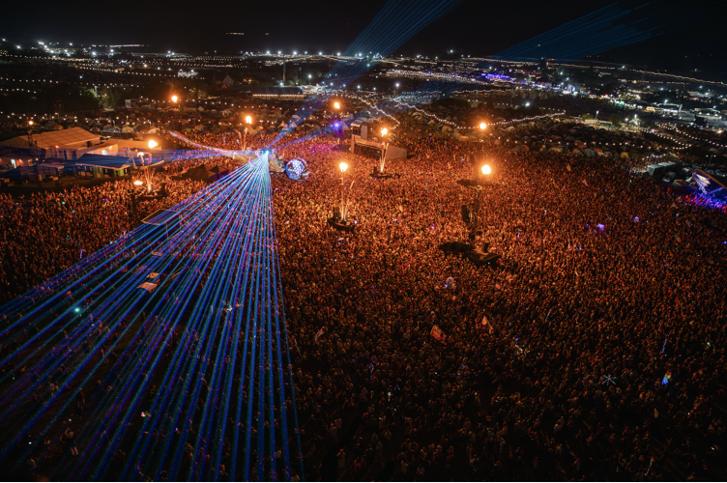

(Ends)

The high-resolution images accompanying this media release can be downloaded here.

About the Sennheiser Brand – 80 Years of Building the Future of Audio
We live and breathe audio. We are driven by the passion to create audio solutions that make a difference. This passion has taken us from the world’s greatest stages to the quietest listening rooms – and made Sennheiser the name behind audio that doesn’t just sound good: It feels true. In 2025, the Sennheiser brand celebrates its 80th anniversary. Since 1945, we stand for building the future of audio and bringing remarkable sound experiences to our customers. While professional audio solutions such as microphones, meeting solutions, streaming technologies and monitoring systems are part of the business of Sennheiser electronic SE & Co. KG, the business with consumer devices such as headphones, soundbars and speech-enhanced hearables is operated by Sonova Holding AG under the license of Sennheiser.

www.sennheiser.com
www.sennheiser-hearing.com

EMEA Press Contact
Maik Robbe
Maik.Robbe@sennheiser.com
+49 (5130) 600 – 1028

